iOS INTERNSHIP JUNE 2024

Project report

On

EasyCart

Submitted by: -

Saloni Singh

[Saloniisingh93@gmail.com](mailto:Saloniisingh93@gmail.com)

Case Study

1.1 Introduction

“Users often forget items while shopping or have trouble organizing their lists. The shopping list App aims to solve these problems by providing a user-friendly platform to create, manage, and categorize shopping lists. This results in more organized shopping, saving time and reducing errors.”

1.2 Solution

EasyCart solves the inefficiencies of traditional shopping by providing a user-friendly platform to create, manage and share shopping lists digitally.

**The app offers:**

* **Seamless List Management:** Users can easily create, update, and organize lists by category or store, reducing time spent searching for items.
* **Set Quantities:** Allows user to set quantities of items.
* **User-Friendly UI:** Easy & understandable UI design for users.
* **Sharing Option:** Users can easily share their list with their family & friends.
* **Voice control:** It let users add items, remove items or even delete items from their shopping list app all through simple voice commands for a hands-free experience.
* **Customization Option:** You can customize your lists according to your preference.
* **Offline Functionality:** Now users can access their list without internet.
* **Visual cues:** It helps users interact with app more efficiently & make interface more intuitive.

1.3 Development Process

* Technologies Used

1. Programming Language:

* Swift: The primary language for iOS development, providing performance and ease of use.

1. IDE (Integrated Development Environment):

* Xcode: Apple’s official IDE for iOS development, which includes tools for designing, coding, testing, and debugging.

1. User Interface Framework:

* UI Kit: For building user interfaces programmatically or using Storyboards, supporting event handling, gestures, animations, and more.

1. Data Management:

* Core Data: For managing and persisting data within the app, useful for saving shopping lists locally.

1. Backend and APIs:

* Firebase: A popular backend-as-a-service (BaaS) solution for authentication, database storage, and real-time syncing.

1. Voice Control:

* Sirikit: To enable voice commands for adding items to the shopping list through Siri.
* Speech Recognition API: For adding custom voice control capabilities.

1. Design tools:

* Figma: For designing the app’s user interface and creating prototypes before development.

Workflow

**2.1** User journey:

* Sign Up / Sign In: The user logs in or creates an account.
* Create List: The user creates a new shopping list and adds a title.
* Add items: The user selects a category (E.g., Groceries, Clothes), enters the item name, and set quantity.
* Edit/Update List: The user can update or delete items, checkoff bought items, or adjust quantities.
* Save/Share List: The user saves the list and can optionally share it with friends or family members.

Start



Login

Guest Account

User Account

Add, Edit,Delete & Update List

Save & Share



Logout



Persona

* Primary Persona: Mohan, 32-year-old Parent

Mohan is a father of two who regularly shops for groceries and household items.

* Pain Points:
* Often forgets items on his grocery list.
* Find it difficult to organize and keep track of items while shopping with children.
* Goals:
* Keep a categorized list that’s easy to update during shopping.
* Check off items as they are bought.
* Share the list with his partner.
* Prefers User-friendly interfaces with minimal setup.
* Scenario:

Mohan logs into the app, quickly creates a groceries list by selecting categories like “Produce” and “Dairy”, adds items like milk and apples, sets quantities and saves the list. During his shopping trip, he check offs items as he buys them, and then app automatically updates the remaining items.

Wireframe

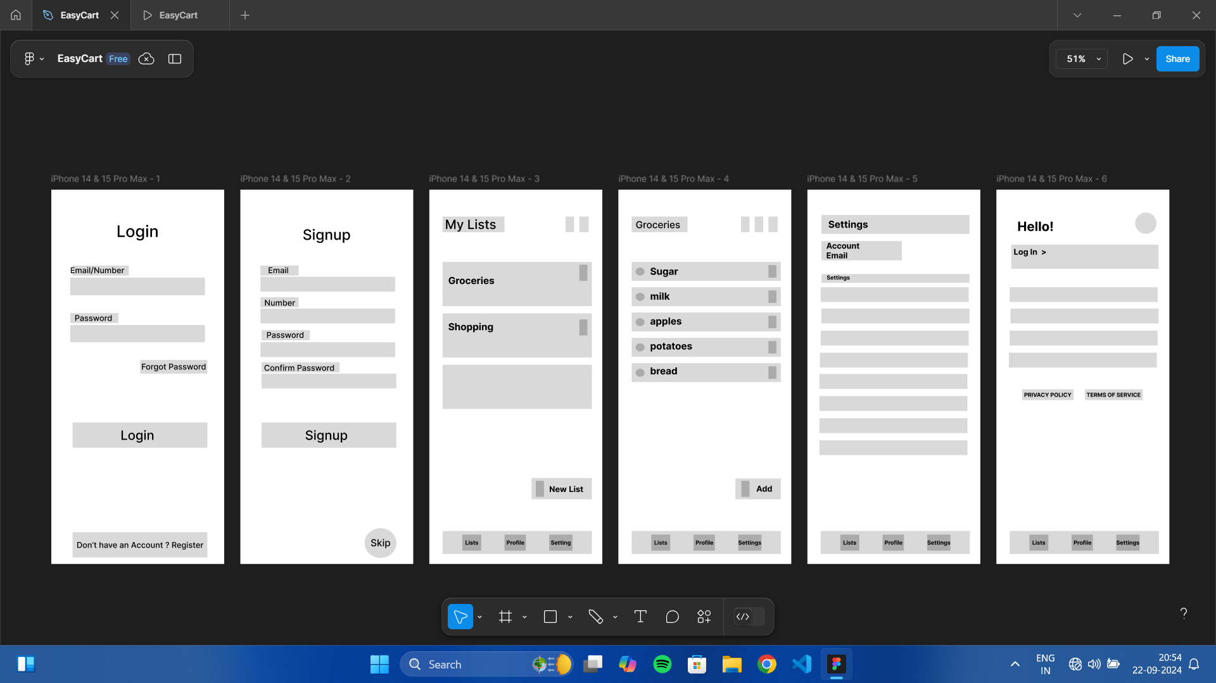

* Wireframe overview:

1. Login Page: User can login in app if they have already created an account in the app before.
2. Signup: User can also register themselves or they can create their account later.
3. Home Screen: The user sees all their active shopping lists. A prominent “New List” button is available at the bottom right. Each list displays the number of items and the categories (e.g., Groceries, Shopping) underneath.
4. List Detail Screen: Shows all items in the list, grouped by category. User can check off items as they’re purchased.
5. Settings Screen: Users can preferences such as notification settings.
6. Profile Screen: User can edit or save their personal details.

Conclusion

EasyCart addresses the everyday challenges of shopping by offering a seamless, user-friendly platform for creating, managing, and sharing shopping lists. Through intuitive design, real-time collaboration, and smart features like voice control, the

App enhances the shopping experience, saving users time and effort.

By leveraging cutting-edge technologies like swift, core Data EasyCart ensures reliability, efficiency, and scalability. We aim to redefine convenience in shopping, making it easer for users to stay organized and within budget.

With continuous updates and features enhancements, EasyCart is set to become an essential tool for everyone looking to streamline their shopping process, both now and in the future.